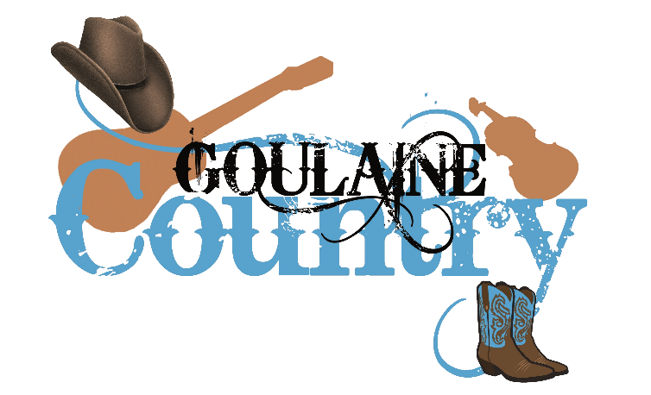**Playlist Fête de la Musique**

**Vendredi 21 juin à 19h30**

***Salle Paul Bouin à Basse Goulaine (44)***

|  |  |  |
| --- | --- | --- |
| **43** | **Road to Errogie** | **I/D** |
| **44** | **Ghost Town** | **D** |
| **45** | **Gypsy queen** | **N** |
| **46** | **Too Many Drunk** | **I** |
| **47** | **Remember D / Love in Mexico** | **D/P** |
| **48** | **The Morning After (PC 23-24)** | **D** |
| **49** | **Martha Divine** | **N** |
| **50** | **Kiss Me** | **I** |
| **51** | **The Road (pc23-24)** | **D** |
| **52** | **TH Guest Ranch** | **I** |
| **53** | **Texas Time** | **D/I** |
| **54** | **Bad Fiddling** | **N** |
| **55** | **Chill Factor / Cowboy Madison** | **I/D** |
| **56** | **Me & You (pc 23-24)** | **D** |
| **57** | **Dim the Lights** | **I** |
| **58** | **Desirable** | **D** |
| **59** | **Sweat and Dust** | **I** |
| **60** | **Done** | **N** |
| **61** | **Thelma & Louise** | **I** |
| **62** | **Dust** | **D** |
| **63** | **Jersey Giant (pc 23-24)** | **N** |
| **64** | **Twist and Turn** | **I** |
| **65** | **Knock Off** | **N** |
| **66** | **Here we Go** | **N** |
| **67** | **You Are** | **I** |
| **68** | **Lonely Drum** | **N** |
| **69** | **Go Cat Go** | **D** |
| **70** | **Right Girl Long Tim (pc 23-24)** | **I** |
|  |  |  |
|  |  |  |
|  |  |  |
|  |  |  |
|  |  |  |
|  |  |  |
|  |  |  |
|  |  |  |
|  |  |  |
|  |  |  |
|  |  |  |
|  |  |  |
|  |  |  |
|  |  |  |

|  |  |  |
| --- | --- | --- |
| **1** | **Back to the Start** | **D** |
| **2** | **Ordinary Day - Gaëlle Renard** | **N** |
| **3** | **Day of the Dead** | **N** |
| **4** | **Riser** | **I** |
| **5** | **Wonder / Memory lane (PC 23-24)** | **A / P** |
| **6** | **That Honky Tonk Highway (PC 23-24)** | **D** |
| **7** | **Razor Sharp** | **N** |
| **8** | **Raised Like That** | **I** |
| **9** | **Til’ you Can’t (PC 22-23)** | **A** |
| **10** | **Sangria / Sweet Sangria** | **D/P** |
| **11** | **Texas Hold’em** | **N** |
| **12** | **Double Devil** | **D** |
| **13** | **First Meeting (PC 22-23)** | **N** |
| **14** | **Around the fire - K. Sala C. Durand D…** | **I** |
| **15** | **Get up (PC 22-23)** | **A** |
| **16** | **Billy’s Dance** | **P** |
| **17** | **Flip it (PC 22-23)** | **D** |
| **18** | **Mama & Me (PC 23-24)** | **N** |
| **19** | **Year of the Young - David Lecaillon** | **I** |
| **20** | **The Difference (PC 21-22)** | **A** |
| **21** | **Back Road Nation – Bruno Morel** | **N** |
| **22** | **Heave Away** | **D** |
| **23** | **Irish Boots** | **N+** |
| **24** | **Daytona Sand** | **I** |
| **25** | **Somebody you Love (PC 23-24)** | **A** |
| **26** | **Boys in Boots (PC 23-24)** | **D / P** |
| **27** | **New Friends (PC 23-24)** | **N** |
| **28** | **Love Ain’t** | **D** |
| **29** | **There is a Fire** | **A** |
| **30** | **Wannabes / Wannabes with you** | **N / P** |
| **31** | **Always Humble** | **D** |
| **32** | **Woah! Good Things - David Lecaillon** | **N** |
| **33** | **Now I Know (23-24)** | **I** |
| **34** | **Devil - Stefano Civa** | **N** |
| **35** | **Getting good** | **D** |
| **36** | **Footloose** | **I** |
| **37** | **Just let go - Dan Albro** | **N** |
| **38** | **Ding Dang Darn it (PC 23-24)** | **I** |
| **39** | **Too Many Love Song** | **D** |
| **40** | **The Gambler** | **N** |
| **41** | **My Broken Heart (Garry O’Reilly)/El Paso** | **I/P** |
| **42** | **I hope you’re happy** | **N** |